Sunview Software Round Robin Ticket Assignment Customization

1. Create a Boolean field called “RoundRobin” (without the quotes) under Incident Management > Incident Request > Model > Fields

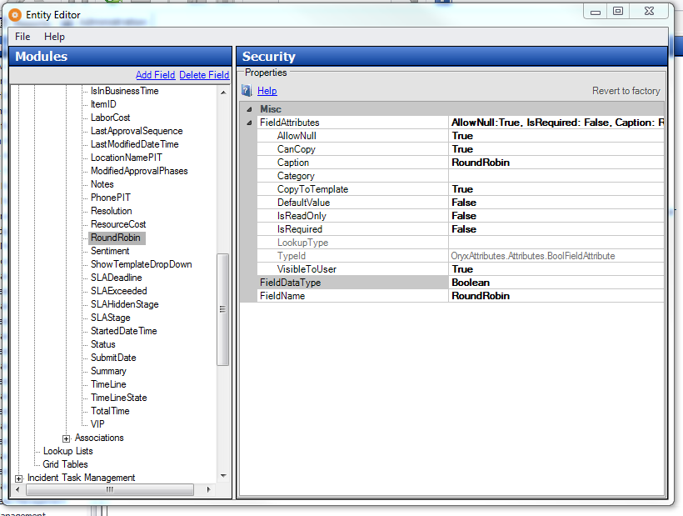

1. Add this Boolean field to the staff form for incident requests
2. Create another Boolean field called “RoundRobinRotation” under Security > Users > Model > Fields

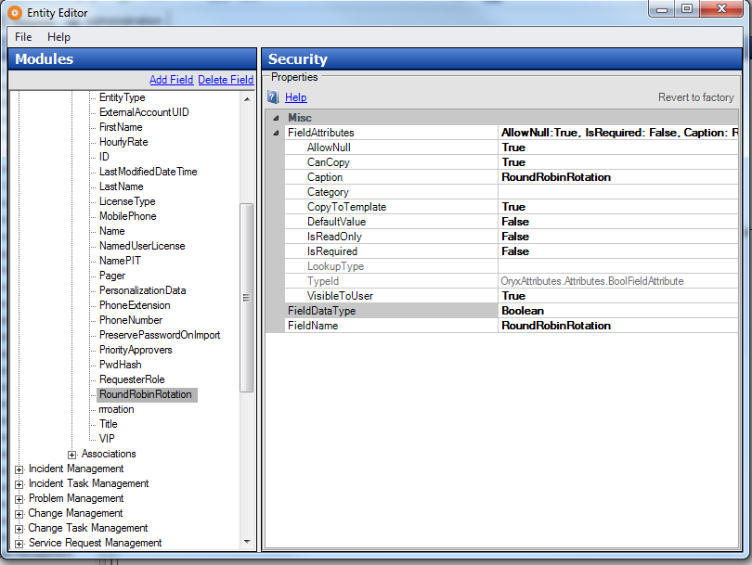

1. Add this Boolean field to the incident staff form
2. Add a new Run Code automation to the Submit action for the active incident workflow and add the contents of the **round_robin.cs** file to the code field. Give the run code automation a description name like “Round Robin Ticket Assignment”
3. Restart the ChangeGear service and Reset IIS
4. Each user who needs to be in the round robin rotation should have the RoundRobinRotation field checked for their profile in ChangeGear.
5. Have a user create a new incident and check the RoundRobin field in a ticket.
6. Hide the RoundRobin and RoundRobinRotation (if necessary) from the users by going to the Entity Editor and toggling their visibility property.
7. Reset IIS